**A Minor Project**

**on**

**Doctor Management App**

**Session 2019-20**

**Submitted to:**

**Amit Kumar Sharma**

**[Asst. Professor ]**

**CSE Department PSITCOE Kanpur**

**Submitted by:**

**Atul Kumar Gupta [1834810023]**

**Dilip Yadav [1834810032]**

**Harshit Mishra [1834810037]**

**Nitin Kumar [1834810062]**

**INTRODUCTION**

Life is becoming too busy to get medical appointments in person and to maintain a proper health care. The main idea of this work is to provide ease and comfort to patients while taking appointment from doctors and it also resolves the problems that the patients has to face while making an appointment. The android application acts as a client whereas the database containing the doctor’s details, patient’s details and appointment details is maintained by a website that acts as a server.

Android is an open source operating system which is Linux based and android platform is used to develop many useful applications for the mobile devices that makes the tasks of everyday life easy and faster. The android platform also provides built in database (SQLite database) and Web services. Android platform provides connectivity between the server and the application using certain APIs, hence the task of making a doctor appointment using a mobile application connected to a website located on the server becomes easy using the advanced features and libraries available on the android platform.

If anybody is ill and wants to visit a doctor for checkup, he or she needs to visit the hospital and waits until the doctor is available. The patient also waits in a queue while getting appointment. If the doctor cancels the appointment for some emergency reasons then the patient is not able to know about the cancellation of the appointment unless or until he or she visits the hospital. As the mobile communication technology is developing rapidly, therefore, one can use the mobile’s applications to overcome such problems and inconvenience for the patients.

The front end design is simple and user-friendly. Once the application is started the patient will register himself and then he will be able to log in into the application. The patient can make an appointment by selecting the preferred doctor, date and time.

**BACKGROUND AND HISTORY**

Healthcare in India is one of the fastest growing sectors in terms of interest, investments and employment. As an industry it comprises of hospitals, medical devices, clinical trials, outsourcing, telemedicine, medical tourism, health insurance and medical equipment. With a largely ‘aware’ customer base exposed to a convergence of services, willingness to explore alternatives in a highly regulated and compliance-based industry, the focus on and the action in the sector is significant in both the public and private categories. The public healthcare system is predominantly limited to secondary and tertiary care institutions in key cities and primary healthcare in rural areas, and private sector caters to a majority of the requirements on secondary, tertiary and quaternary care.  
  
India’s competitive advantage has been that of the ‘demographic dividend’, relatively large pool of well-trained medical professionals and relatively cost-effective complicated life-saving clinical procedures. However, such a platform will be deemed to be of any promise provided it is sustainable and improvable.

In the 21st Century, health care systems across the world are focusing policy efforts on improving the quality of healthcare delivered to their population. In contrast, healthcare quality improvement in earlier time periods arose from a series of seemingly unrelated incidents and developments. In this paper, we sequentially review key international historical events that improved health care quality during the years 1860–1960, including innovation in health care financing, care delivery and workforce diversity. The modern nursing workforce of today continues to encounter many of these same challenges across the globe.

Health and health care need to be distinguished from each other for no better reason than that the former is often incorrectly seen as a direct function of the latter. Heath is clearly not the mere absence of disease. Good Health confers on a person or groups freedom from illness - and the ability to realize one's potential. Health is therefore best understood as the indispensable basis for defining a person's sense of well being. The health of populations is a distinct key issue in public policy discourse in every mature society often determining the deployment of huge society. They include its cultural understanding of ill health and well-being, extent of socio-economic disparities, reach of health services and quality and costs of care. and current bio-mcdical understanding about health and illness. Health care covers not merely medical care but also all aspects pro preventive care too. Nor can it be limited to care rendered by or financed out of public expenditure within the government sector alone but must include incentives and disincentives for self care and care paid for by private citizens to get over ill health. Where, as in India, private out-of-pocket expenditure dominates the cost financing health care, the effects are bound t be regressive. Heath care at its essential core is widely recognized to be a public good. Its demand and supply cannot therefore, be left to be regulated solely by the invisible had of the market. Nor can it be established on considerations of utility maximizing conduct alone. What makes for a just health care system even as an ideal? Four criteria could be suggested- First universal access, and access to an adequate level, and access without excessive burden. Second fair distribution of financial costs for access and fair distribution of burden in rationing care and capacity and a constant search for improvement to a more just system. Third training providers for competence empathy and accountability, pursuit of quality care ad cost effective use of the results of relevant research. Last special attention to vulnerable groups such a children, women, disabled and the aged.

Traditionally, medical appointments have been made with schedulers over the telephone or in person. These methods are based on verbal communications with real people and allow for maximum flexibility in complicated situations . However, because these traditional methods require the intervention of schedulers, the ability to get a timely appointment is not only limited by the availability of appointment slots, but also by the schedulers and phone lines . Patients’ satisfaction with appointment booking is influenced by their ability to book at the right time with the right health service providers .

The Internet has recently emerged as another means to make appointments. Web-based appointment scheduling has been a popular research topic. Several studies conducted satisfaction surveys and found that Web-based appointment scheduling is an extremely important feature, and most patients would use the service again .

There are two major types of Web-based medical appointment services, medical scheduling software as a service (SaaS) and proprietary Web-based scheduling systems. Medical scheduling SaaS has gained increasing prominence in recent years. These appointment systems are not built up by health care practices themselves, but are provided and maintained by health IT companies such as ZocDoc and InQuicker on a paid subscription basis . The appointment services are cloud-based and can be integrated into health care providers’ own management systems. The other type of appointment service is proprietary appointment systems, which are integrated into patient portals on providers’ websites . A patient portal is a secured Web-based service that allows patients to access their health information and communicate with their health care providers at any time . In the United States, the growth of patient portals has largely been spurred by meaningful use (MU) requirements because of the federal incentive program for adoption of electronic health records. To meet the requirements of MU and receive its incentives, the portal should be actively used by both the practice and patients .

**TABLE OF CONTENTS**.

* **INTRODUCTION**
* **BACKGROUND AND HISTORY**
* **BLOCK DIAGRAM**
* **PROJECT DESCRIPTION**
* **CASE DIAGRAM**
* **CONCLUSION**
* **REFERENCES**

**Project Description**

1) **Software Requirement:**

* + Operating System : Window XP, Windows
  + Android studio 2.1.1 and SDK plug-in
  + JDK 6
  + Android 6.0 (Marshmallow) installed packages

2) **Hardware Requirement:**

* + Processor: Pentium IV Processor
  + RAM: 64MB SD-RAM
  + HDD: 20 GB Ultra ATA
  + Monitor: 15'' Color
  + Keyboard, Mouse

**3) Project Module:**

Project Module Consists of two major Parts:

**a)Doctor**

* Doctor Login: Doctor is one who will be able to whom appointment will be fixed by patient.
* Doctor dashboard: It will consist of doctor homepage, his appointment details, his appointment history and his personal details.

**b)Patient**

* Patient Login:Patient is one who will make his appointment to doctor and will be able to take various health issue concern.
* Patient Dashboard: It will consist of patient homepage, his appointment details, his appointment history and his personal details.

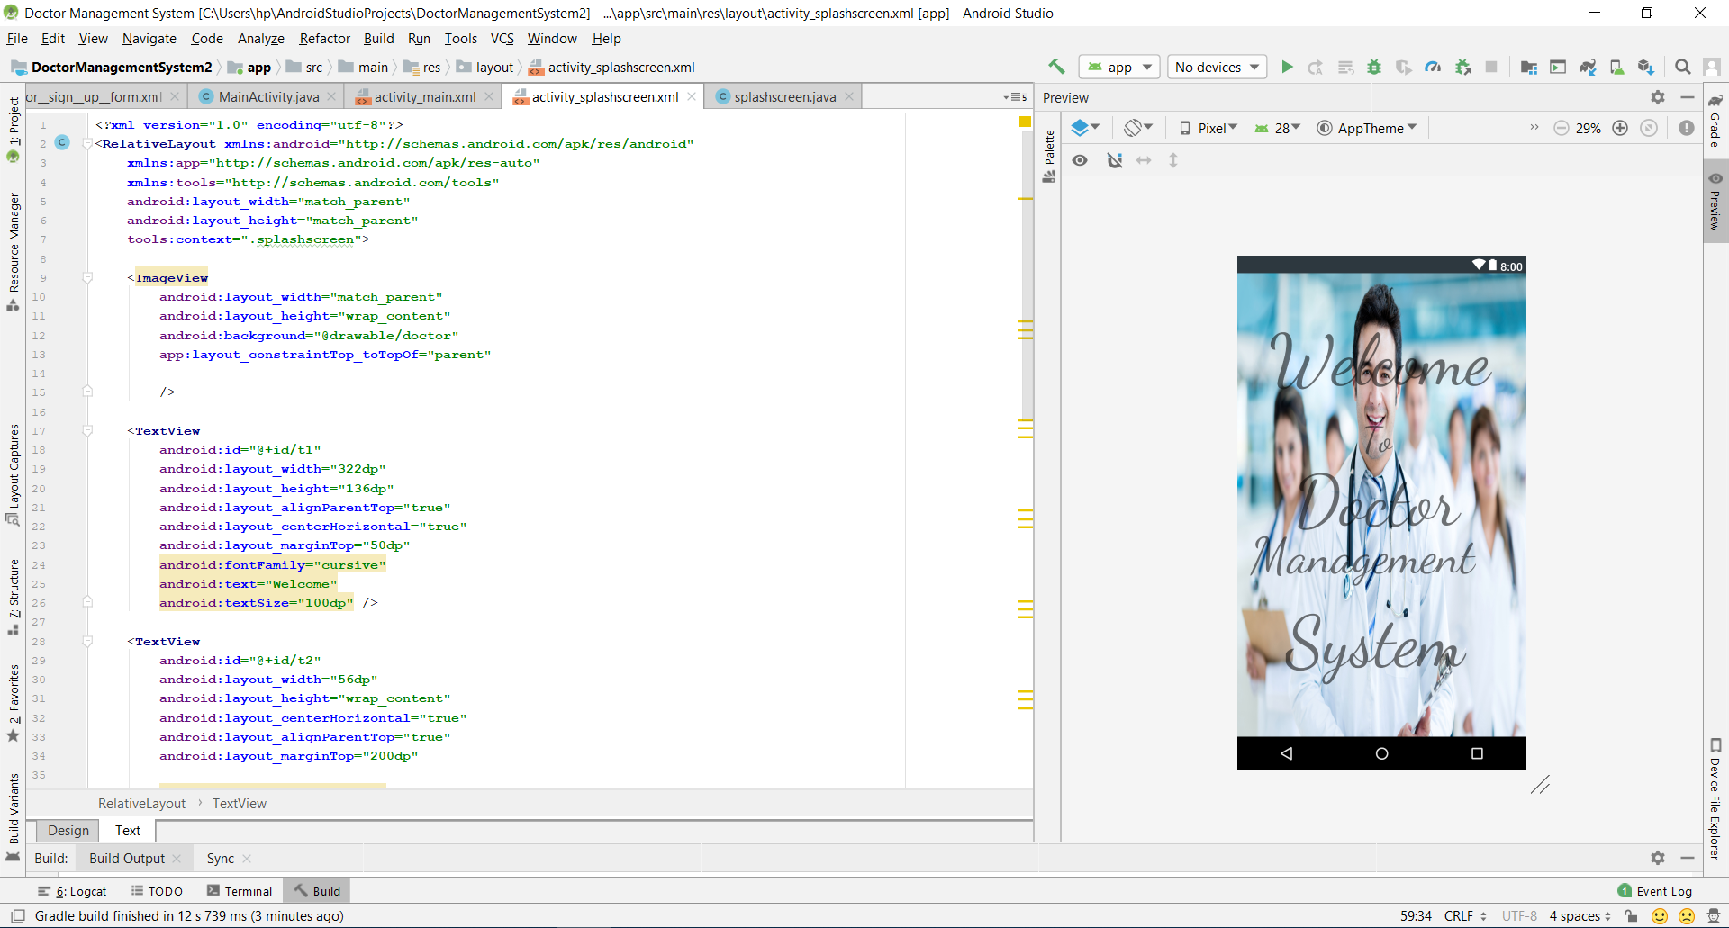

**Conclusion**

The proposed online appointment system has been implemented in android studio for application development and website is developed using ANDROID STUDIO. The tasks involved in this work are divided into modules. The data is approached and shared by using API’S between the website and the android application. The proposed system is efficient and has friendly user interface. Addition of the patient and doctor modules in the android application are included in future work. That would help the doctor to register on the application and perform all the tasks on the app. A payment or some amount may be charged to the users/patients while making an appointment to avoid the unethical users. As many users only register themselves just for fun and has no concern by making an appointment. Some more future directions are the improvements in the patient’s module which includes setting reminders for the appointments and saving the appointment date to the calendar.

**References**

* [1] Arthur Hylton III and Suresh Sankaran arayanan “Application of Intelligent Agents in Hospital Appointment Scheduling System”, International Journal of Computer Theory and Engineering, Vol. 4, August 2012, pp. 625-630.
* [2] Deepti Ameta, Kalpana Mudaliar and Palak Patel “Medication Reminder And Healthcare – An Android Application”, International Journal of Managing Public Sector Information and Communication Technologies (IJMPICT) Vol. 6, June 2015, pp. 39-48.
* [3] Yeo Symey, Suresh Sankaran arayanan, Siti Nurafifah binti Sait “Application of Smart Technologies for Mobile Patient Appointment System”, International Journal of Advanced Trends in Computer Science and Engineering, august 2013.
* [4] Jagannath Aghav, Smita Sonawane, and Himanshu Bhambhlani “Health Track: Health Monitoring and Prognosis System using Wearable Sensors”, IEEE International Conference on Advances in Engineering & Technology Research 2014, pp. 1-5.
* [5] YoeSyMey and Suresh Sankaranarayanan “Near Field Communication based Patient Appointment”, International Conference on Cloud and Ubiquitous Computing and Emerging Technologies, 2013, pp.98-103.
* [6] RashmiA.Nimbalkar and R.A. Fadnavis “Domain Specific Search of Nearest Hospital and Healthcare Management System”, Recent Advances in Engineering and Computational Sciences (RAECS), 2014, pp.1-5.
* [7}A. Luschi, A. Belardinelli, L. Marzi, F. Frosini, R. Miniati and E. Iadanza “Careggi Smart Hospital: a mobile app for patients, citizens and healthcare staff”, IEEE-EMBS International Conference on Biomedical and Health informatics (BHI), 2014, pp.125-128.
* [8] Choi, J. ; Biomed lab Co., Seoul, South Korea ; Kang, W.Y. ; Chung, J. ; Park, J.W. “Development Of An Online Database System For Remote Monitoring Of Artificial Heart Patient”,Information Technology Applications in Biomedicine, 2003. 4th International IEEE EMBS Special Topic Conference, 24-26 April 2003
* [9] Prof. S. B. Choudhari, ChaitanyaKusurkar, RuchaSonje, ParagMahajan, Joanna koVaz “Android Application for Doctor‟s Appointment”, International Journal of Innovative Research in Computer and Communication Engineering, January 2014
* [10] S.Gavaskar, A. Sumithra, A.Saranya “Health Portal-An Android Smarter Healthcare Application”, International Journal of Research in Engineering and Technology, Sep-2013.
* [11]Frank Sposaro and Gary Tyson, “iFall: An android application for fall monitoring and response”, 31st Annual International Conference of the IEEE Engineering in Medicine and Biology Society, 1:6119–22, 2009.
* [12] Pei-Fang Tsai, I-sheng Chen, and Keven Pothoven “Development of Handheld Healthcare Information System in an Outpatient Physical Therapy Clinic”, proceedings of the 2014 IEEE 18th International Conference on Computer Supported Cooperative Work in Design, pp. 559-602.
* [13] Jin Wang, Richard Y.K. Fung “adaptive dynamic programming algorithms for sequential appointment scheduling with patient preferences”, Science Direct, Artificial Intelligence in Medicine January 2015, Pages 33–40.

**BLOCK DIAGRAM**

